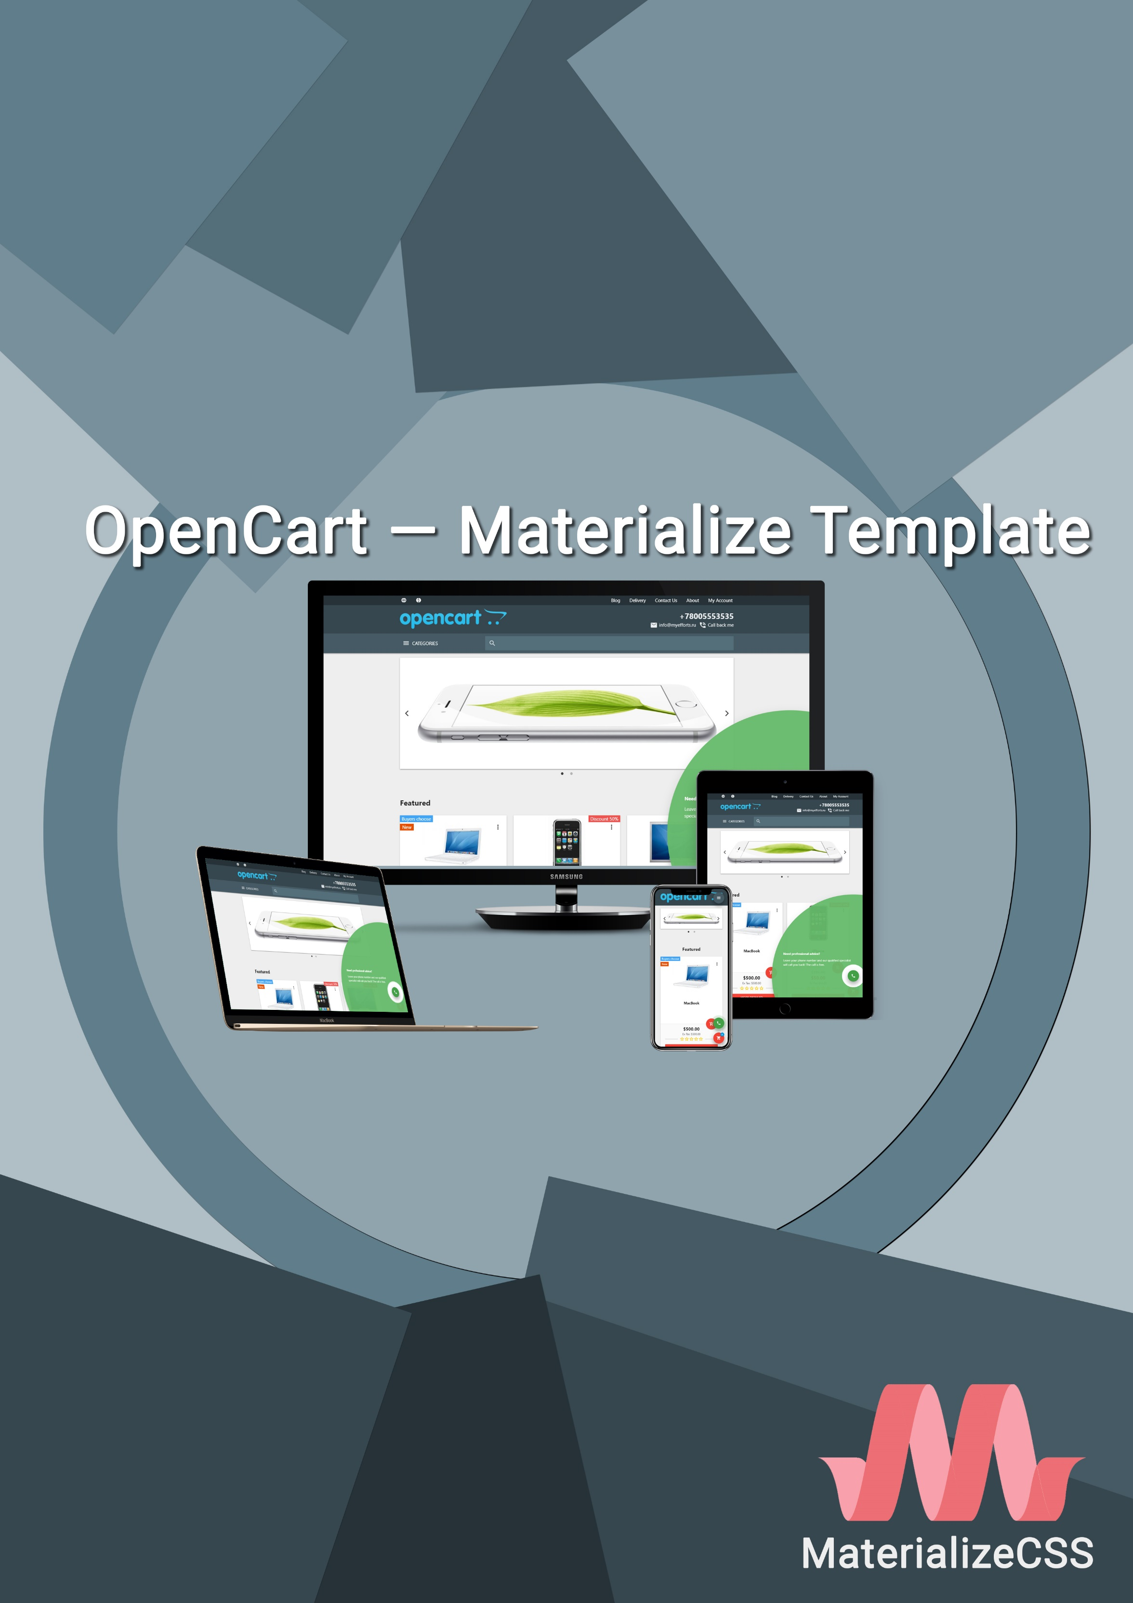

Table of contents

Template installation 3

Module «Materialize "Blog"» 6

Module Materialize "Call Back" 8

Module Materialize "Quick order" 10

Module Materialize "Size Chart" 11

Module Materialize "Labels" 13

Module Materialize "Map" 14

Module Custom Tabs 15

Module Additional Fields 16

Technical support and translation 17

Project and developer support 18

Template installation

|  |  |
| --- | --- |
| 1. Open your admin panel select **«Extensions»** in the left menu and open **«Installer»**. |  |
| 1. Click the «**Upload»** button and select **Materialize_Template_v0.80_oc3.0.x.ocmod.zip**. |  |
| 1. Select **«Extensions»** and open **«Modifications»**. |  |
| 1. In the upper right corner, click the **«Refresh»** button. |  |
| 1. In the left menu select **«Extensions»** and open **«Extensions»**, select **«Themes»**. On the contrary, to the **«Materialize Template»** click the **«Install»** button. |  |
| 1. After installation, on the same page, click the **«Edit»** button. |  |
| **Please check out the pop-up window, I would be happy with any of your support.** | |
| 1. On the right, change the status of the theme to **«Enabled»** and click the **«Save»** button. |  |
| 1. In the left menu select **«System»** and open **«Settings»**. |  |
| 1. Click the **«Edit»** button of your store. |  |
| 1. In the **«General»** tab, change the theme to **«Materialize Template»**, then in the upper right corner click the **«Save»** button. |  |

Deleting a template

1. Open your admin panel, in the left menu select **«Extensions»** and open **«Extensions»**, select **«Themes»**.
2. On the contrary, to the **«Materialize Template»** click the **«Uninstall»** button.
3. In the left menu select **«Extensions»** and open **«Installer»**.
4. On the contrary, to **Materialize_Template_v0.80_oc3.0.x.ocmod.zip**, click the **«Unisntall»** button.
5. In the left menu select **«Extensions»** and open **«Modifications»**.
6. In the upper right corner, click the **«Refresh»** button.
7. In the left menu, select **«System»** and open **«Settings»**.
8. Click the **«Edit»** button of your store.
9. In the **«General»** tab, change the theme to **«Default Store Theme»**, then in the upper right corner click the **«Save»** button.

Module «Materialize "Blog"»

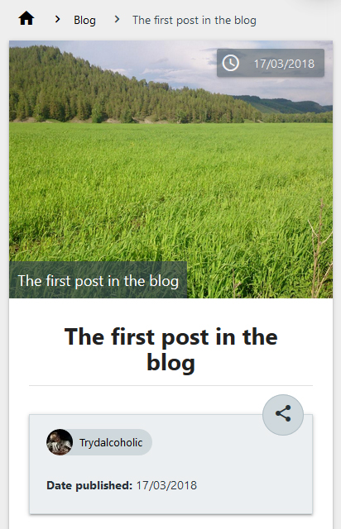

Installing the module

1. Open your admin panel, in the left menu select **«Extensions»** and open **«Extensions»**, select **«Modules»**.
2. On the contrary, to the **«Materialize "Blog"»** click the **«Install»** button, then click **«Edit»**.
3. **Please check out the pop-up window, I would be happy with any of your support.**
4. In the **«General»** tab, specify the name for the module, for example, **«Blog»**.
5. On the right, change the status of the module to **«Enabled»**, then click **«Save»**.
6. In the left menu select **«Design»** and open **«Layouts»**.
7. Opposite the **«Blog»** then click **«Edit»**.
8. Select the location of the module, for example, click on the **«Right column»** and add **«Materialize "Blog"»**, then in the upper right corner click the **«Save»** button.

Adding categories

1. In the left menu, select **«Materialize Template»**, select **«Blog»** and open **«Categories»**.
2. In the upper right corner, click the **«Add»** button.
3. In the **«General»** tab, specify the category name.
4. On the right, click the **«Save»** button.

Adding author

1. In the left menu, select **«Materialize Template»**, select **«Blog»** and open **«Authors»**.
2. In the upper right corner, click the **«Add»** button.
3. In the **«General»** tab, specify the author's name.
4. In the upper right corner, click the **«Save»** button.

Adding post

1. In the left menu select **«Materialize Template»**, select **«Blog»** and open **«Posts»**.
2. In the upper right corner, click the **«Add»** button.
3. In the **«General»** tab, specify the name of the post.
4. On the right, click the **«Save»** button**.**

Deleting Module

This action will also remove blog categories, blog authors, blog posts and blog comments.

1. Open your admin panel select **«Extensions»** in the left menu and open **«Extensions»**, select **«Modules»**.
2. Opposite the **«Materialize "Blog"»**, click the **«Uninstall»** button.

Module Materialize "Call Back"

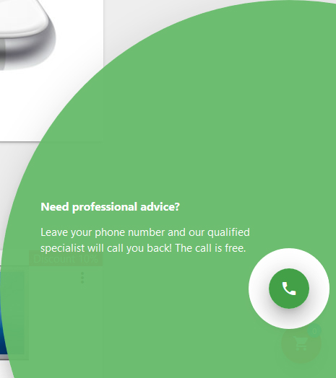

Installing the module

1. Open your admin panel select **«Extensions»** in the left menu and open **«Extensions»**, select **«Modules»**.
2. Opposite the **«Materialize "Call Back"»**, click the **«Install»** button, then click the **«Edit»** button.
3. **Please check out the pop-up window, I would be happy with any of your support.**
4. Fill in the required fields: **«Title»**, **«Text after sending»** and **«Button text»**.
5. On the right, change the status of the module to **«Enabled»**, then click **«Save»**.

Working with the module

In the module settings, you can specify additional fields for filling by the user, making them mandatory, at will.

To include a round button that attracts the attention of website visitors, use the function **«Call to action»**, changing the corresponding status to **«Enabled»**. Fill in the required fields: **«Title»,** **«Description»** and **«Time to Appearance»** (the time of inactivity of visitors to the site, after which the button will open independently).

In the advanced settings, you can specify an agreement with the rules. For example, if you need to notify users about data processing rules.

**The module by default receives the IP address of the devices from which data will be entered into the Call Back module**.

The notification of the received callback request and all the data entered by the users will be automatically sent to the e-mail specified in the store settings, including the additional addresses.

In the 0.78 version of the template, a form for processing incoming call back orders was added. In the left menu, select **«Materialize Template»**, **«Call Back»** and open **«Call Back»**.

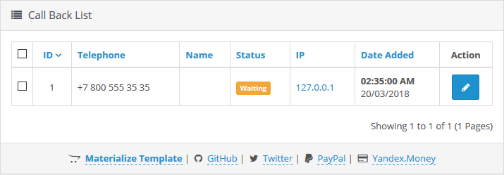

This page displays all the received call back orders with the ability to filter the list. To start working with the call back order, click the **«Edit»** button in the **«Action»** column, opposite the corresponding call back order.

The **«General»** tab displays information entered by the user. Also, the automatically received IP address and the page of the site on which the user made a decision to fill out the Call back form.

In the **«History»** tab you can add comments to the relevant call back order.

On the right you can change the status of the call back order. An call back order can only accept two statuses: **«Waiting»** and **«Called»**.

Deleting Module

This action will also delete the all call back requests.

1. Open your admin panel, select **«Extensions»** in the left menu and open **«Extensions»**, select **«Modules»**.
2. Opposite to the **«Materialize "Call Back"»** button, click the **«Uninstall»** button.

Module Materialize "Quick order"

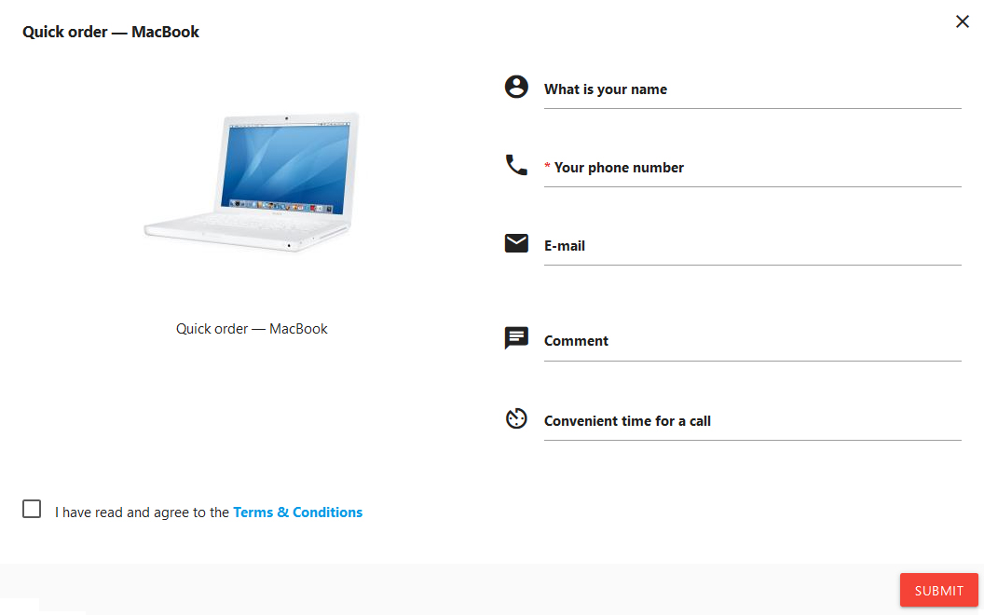

Installing the module

1. Open your admin panel, select **«Extensions»** in the left menu and open **«Extensions»**, select **«Modules»**.
2. Opposite the **«Materialize "Quick Order"»** click the **«Install»** button, then click the **«Edit»** button.
3. **Please check out the pop-up window, I would be happy with any of your support.**
4. In the **«General»** tab, fill in the required fields **«Text after sending»** and **«Button text»**.
5. On the right, change the status of the module to **«Enabled»**, then click **«Save»**.

Request received through the «Quick Order» module come to the e-mail specified in the store settings, including additional addresses. **The module by default receives the IP address of the devices from which data will be entered into the Quick order module**.

Deleting Module

1. Open your admin panel select **«Extensions»** in the left menu and open **«Extensions»**, select **«Modules»**.
2. Opposite the **«Materialize "Quick Order"»** click the **«Uninstall»** button.

Module Materialize "Size Chart"

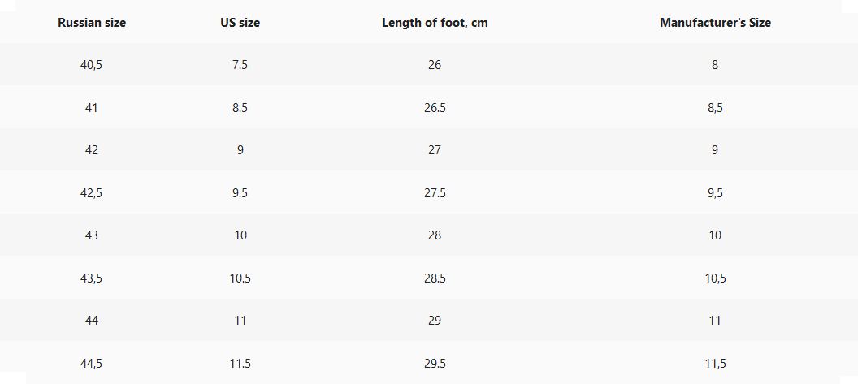

Installing the module

1. Open your admin panel select **«Extensions»** in the left menu and open **«Extensions»**, select **«Modules»**.
2. Opposite the **«Materialize" Size Chart"»**, click the **«Install»** button, then click the **«Edit»** button.
3. **Please check out the pop-up window, I would be happy with any of your support.**
4. Change the status of the module to **«Enabled»**, then in the upper right corner click the **«Save»** button.

Working with the module

The functionality of the module is designed to work for site managers and simplify the work with the size charts. Administrator or site manager in advance fills in the necessary size charts. Then you can assign the saved size chart to the corresponding product. The module suggests dividing the size charts into groups. For example, the group: «Adidas clothing sizes» will include tables «Men's Clothing», «Women's Clothing», «Children's Clothing»:

* **Adidas clothing sizes**
  + Men's Clothing
  + Women's Clothing
  + Children's Clothing

Thus, in the «Adidas clothing sizes» group, 3 size tables will be saved. It is for this logic that the module works. You can use this logic at your discretion, for example, create a group «Adidas Dimensions» and fill it with the tables listed above, adding to their sizes of shoes, etc.

In the left menu, select **«Materialize Template»** and open the **«Size Charts»**. In the upper right corner, click the **«Add New»** button. Specify **«Size Chart Group Name»**, in the **«Size Charts»** section, add a size tables corresponding to this group. In the visual editor, you can not only be limited to the size table, if you wish, you can add images and various descriptions, for example, helping site visitors determine their size. After filling in the required fields, in the upper right corner click the **«Save»** button.

Go to the product editing. Open the **«Links»** tab, in front of the **«Size Charts»**, click in the input field and start typing the name of the required table, then select it from the drop-down list. In the upper right corner click the **«Save»** button.

Deleting Module

This action also deletes the created size tables.

1. Open your admin panel select **«Extensions»** in the left menu and open **«Extensions»**, select **«Modules»**.
2. Opposite the **«Materialize "Size Chart"»**, click the **«Uninstall»** button.

Module Materialize "Labels"

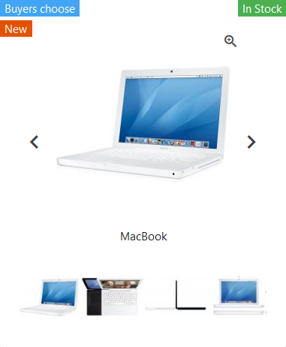

Installing the module

1. Open your admin panel select **«Extensions»** in the left menu and open **«Extensions»**, select **«Modules»**.
2. In front of the **«Materialize "Labels"»** click the **«Install»** button, then click the **«Edit»** button.
3. **Please check out the pop-up window, I would be happy with any of your support.**
4. Change the status of the module to **«Enabled»**, then in the upper right corner click the **«Save»** button.

Working with the module

In the left menu, select **«Materialize Template»** and open **«Labels»**. In the upper right corner, click the **«Add New»** button. Specify a name for the label, select a color. In the upper right corner click the **«Save»** button.

Go to the product editing. Open the **«Links»** tab, opposite the **«Labels»** check the label. In the upper right corner click the **«Save»** button.

Deleting Module

This action also removes the created labels.

1. Open your admin panel select **«Extensions»** in the left menu and open **«Extensions»**, select **«Modules»**.
2. In front of the **«Materialize "Labels"»** click the **«Uninstall»** button.

Module Materialize "Map"

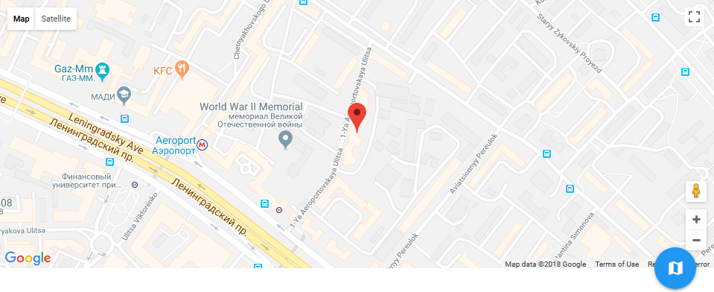

Installing the module

1. Open your admin panel select **«Extensions»** in the left menu and open **«Extensions»**, select **«Modules»**.
2. Opposite the **«Materialize "Map"»**, click the **«Install»** button, then click the **«Edit»** button.
3. **Please check out the pop-up window, I would be happy with any of your support.**
4. Choose a map for your site from two possible: Google Maps (you must register your own **Google API Key**) or Yandex.Maps.
5. Specify the coordinates in the appropriate fields.
6. On the right, change the status of the module to **«Enabled»**, then click **«Save»**.

Working with the module

In the Description field, you can specify a description that will be displayed when the user clicks on the button that indicates the point on the map. Provide here the user with additional useful information, for example, store hours.

**«Icon Pin»** — allows you to replace the standard button on the map with your own image. Be sure to specify the size for this image!

Deleting Module

1. Open your admin panel select **«Extensions»** in the left menu and open **«Extensions»**, select **«Modules»**.
2. In front of the **«Materialize "Map"»**, click the **«Uninstall»** button.

Module Custom Tabs

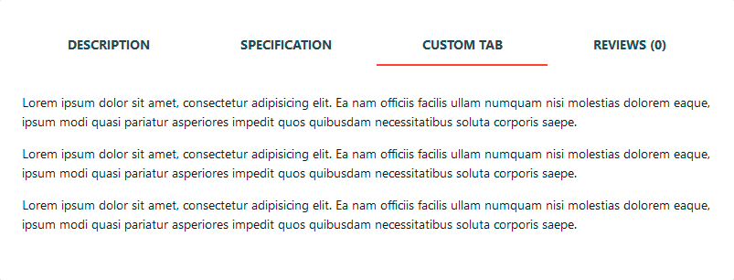

The module is the integration of the original module: [Tmd product custom tab Multilanguage](https://www.opencart.com/index.php?route=marketplace/extension/info&extension_id=25379)

Installing the module

1. Open your admin panel select **«Extensions»** in the left menu and open **«Extensions»**, select **«Modules»**.
2. Opposite the **«Custom tabs»**, click the **«Install»** button, then click the **«Edit»** button.
3. **Please check out the pop-up window, I would be happy with any of your support.**
4. Change the status of the module to **«Enabled»**, then in the upper right corner click the **«Save»** button.

Working with the module

Go to the product editing. Click the **«Custom tab»** tab, add the required tab. In the upper right corner click the **«Save»** button.

Deleting Module

This action also removes information from the created tabs.

1. Open your admin panel select **«Extensions»** in the left menu and open **«Extensions»**, select **«Modules»**.
2. Opposite the **«Custom Tabs»**, click the **«Uninstall»** button.

Module Additional Fields

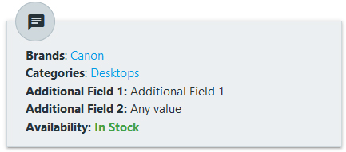

The module is a modified module: [Tmd product custom tab Multilanguage](https://www.opencart.com/index.php?route=marketplace/extension/info&extension_id=25379)

Installing the module

1. Open your admin panel select **«Extensions»** in the left menu and open **«Extensions»**, select **«Modules»**.
2. Opposite the **«Additional Fields»**, click the **«Install»** button, then click the **«Edit»** button.
3. **Please check out the pop-up window, I would be happy with any of your support.**
4. Change the status of the module to **«Enabled»**, then in the upper right corner click the **«Save»** button.

Working with the module

Go to the product editing. Click the **«Additional field»** tab, add the required field. In the upper right corner click the **«Save»** button.

Deleting Module

This action also removes information from the created additional fields.

1. Open your admin panel select **«Extensions»** in the left menu and open **«Extensions»**, select **«Modules»**.
2. Opposite the **«Additional fields»**, click the **«Uninstall»** button.

Technical support and translation

Getting technical support

Please, first, read the documentation. Please make sure that the problem is related to the work of the template or built-in modules **(about problems with third party modules, please contact the developers of these modules)**. For example, the problem does not occur with the standard OpenCart template. To get technical support, open the template page on the [OpenCart Marketplace](https://goo.gl/h2neQk), on the right click on the button **«Get Support»**.

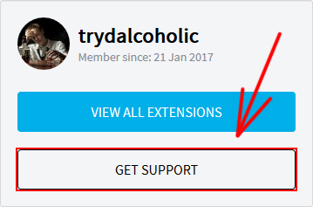

When creating a ticket, please try to provide as much useful information as possible:

* Specify which version of OpenCart you are using;
* Specify the template version;
* Have you installed third-party modules.

GitHub

The project has a repository on [GitHub](https://goo.gl/NTv2W2). Here you can find the latest version of the template, contribute to the development of the project, report errors in the work of the template, or discuss the issue of improving the functions of the template or its modules. Please, if you are plan to report an error, please read the documentation, and then use the search for issue. If you did not find a solution to the error in the documentation or in the previously created issues, create a new issue. Be sure to check out the recommendations for creating a new issue.

Template translation

If you have the opportunity and desire, you can help with the translation of the template into other languages. In addition, you can suggest adjustments for an existing translation. More information in the [discussion on GitHub](https://goo.gl/HyWUfi).

Project and developer support

Reviews on the OpenCart Marketplace

|  |  |
| --- | --- |
| Please rate Materialize Template:   * Open your account on the OpenCart Marketplace * Select «Rate your Donwloads» * Select «Materialize Template» * Post an honest assessment and leave your feedback :) |  |

Donations

|  |  |
| --- | --- |
| Please support the development of the template with your donations:   * [PayPal](https://goo.gl/y6TqzB) * [Yandex.Money](https://goo.gl/z3GXqH) |  |